Notes:

1.Question 1, 6,7 is compulsory

2.Use Bootstrap for below questions

1.

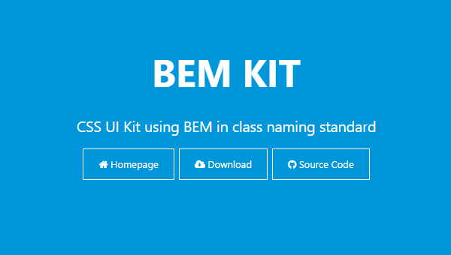

2.

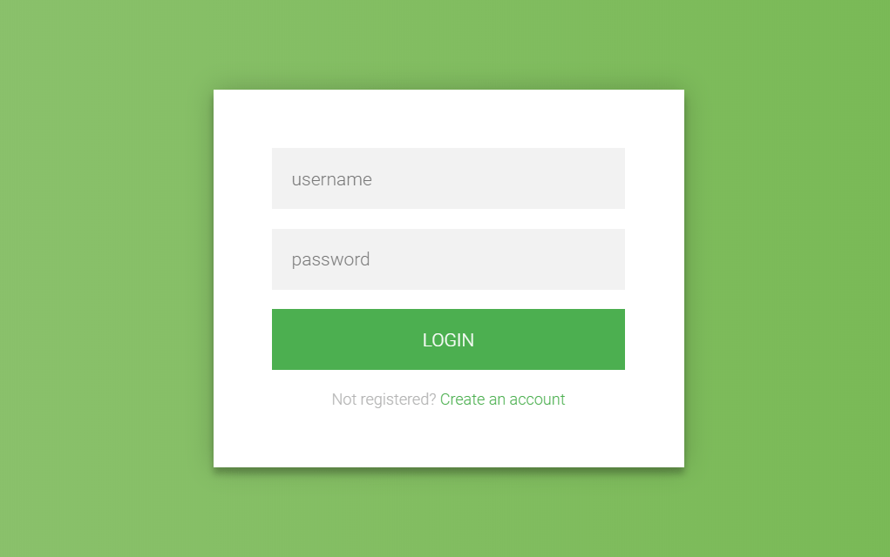

3.



4.

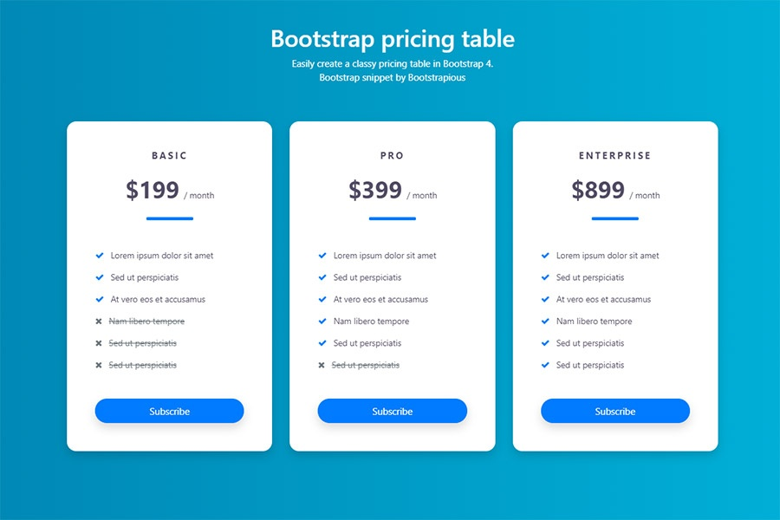

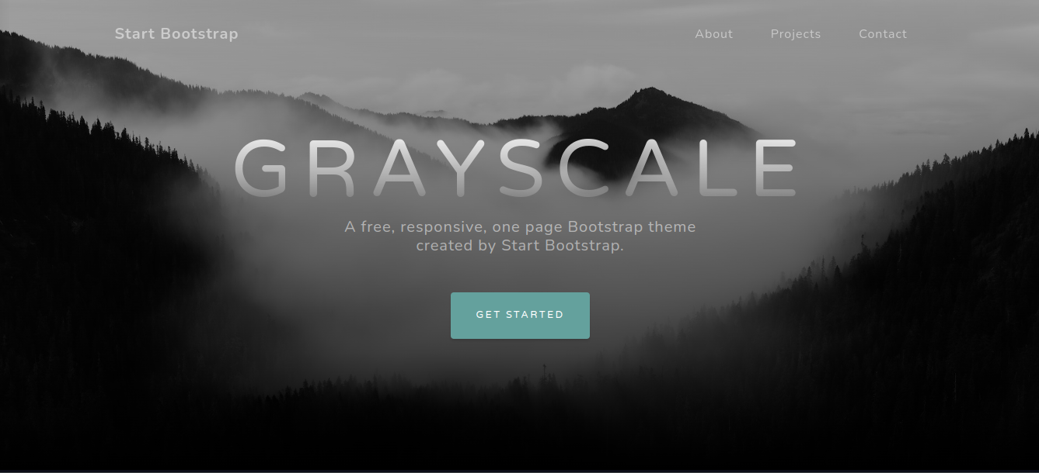

5.

6. Complete the example in given link:

<https://getbootstrap.com/docs/5.3/examples/pricing/>

7.Complete the example in given link:

<https://getbootstrap.com/docs/5.3/examples/checkout/>